[](http://www.google.co.in/imgres?imgurl=http://rfri.icfre.gov.in/ImageRFRI/icfreLogo.gif&imgrefurl=http://rfri.icfre.gov.in/&usg=__tnIZToK2GLatNjpkWYfbSH8eeqA=&h=1053&w=1056&sz=230&hl=en&start=1&zoom=1&tbnid=mpC2Bf-qckageM:&tbnh=150&tbnw=150&ei=9JQYUYfJCYfkrAeCmIGwCg&prev=/search?q=icfre+emblom&um=1&hl=en&sa=N&gbv=2&tbm=isch&um=1&itbs=1&sa=X&ved=0CCkQrQMwAA)वनआनुवंशिकीएवंवृक्षप्रजननसंस्थान

**INSTITUTE OF FOREST GENETICS & TREE BREEDING**

*भारतीयवानिकीअनुसंढानएवंशिक्षापरिषद*

*(INDIAN COUNCIL OF FORESTRY RESEARCH & EDUCATION)*

स्वायत्तनिकाय/ An Autonomous Body of

पर्यावरण, वनएवंजलवायुपरिवर्तनमंत्रालय, भारतसरकार

Ministry of Environment, Forests and Climate Change, Govt. of India

फॉरेस्टकेम्पस,काउलीब्राउनरोड, आर.एस.पुरम, कोयम्बत्तूर – 641002 (T.N)

Forest Campus, Cowly Brown Road, R.S.Puram, Coimbatore – 641002 (T.N)

PH: 0422-2484100, FAX: 2430549, www.ifgtb.icfre.gov

_________________________________________________________________________________

पत्रसं./Lr.No.CTR-I/24-124/2020/Deputationदिनांक/Date: 21/12/2022

**NOTIFICATION**

The Institute of Forest Genetics &Tree Breeding (IFGTB), Coimbatore (T.N) invites applications from the eligible officials under Central/State/Public Sector Undertakings/Autonomous Bodies/Statutory Bodies for filling up of one post of Forester in the Pay Level-4 of 7th CPC Pay Matrix and one post of Dy.Ranger in the Pay Level of 6 of 7th CPC Pay Matrix plus usual allowances as admissible under rules in Indian Council of Forestry Research & Education (ICFRE), Dehradun.

**ELIGIBILITY:**

|  |  |  |
| --- | --- | --- |
| 1. | **Dy.Ranger**: | Analogous Post (OR) |
|  |  | Foresters in the Level-4 of 7th CPC Pay Matrix with 10 years of service in the grade and having successfully completed Forestry training course from a recognized Institution.  ­ |
| 2. | **Forester**: | Analogous Post (OR) |
|  |  | Forest Guard in the Level-2 of 7th CPC Pay Matrix with 08 years of service in the grade and having successfully completed Forestry training course from a recognized Institution. |

**TENURE**: The tenure shall ordinarily be 3 years. The tenure, is however, liable to be terminable at an earlier date or extendable at the discretion of Director, IFGTB, Coimbatore.

**AGE LIMIT: The upper age limit to apply for the above posts is 56 only as on closing date.**

**GENERAL INSTRUCTIONS:**

1. Applications with complete bio-data together with a fee of Rs.500/- (Rs. Five Hundred Only) in the form of Demand Draft drawn in favour of the Director, IFGTB payable at Coimbatore should reach the office of the Director, IFGTB, Forest Campus, R.S.Puram, Coimbatore(TN), PIN: 641002 **on or before 28/02/2023**.
2. Separate applications should be submitted along with Demand Draft of Rs.500/- for each post if a candidate wishes to apply more than one post.
3. Application and the envelope should be superscribed as ‘Application for the post of Dy.Ranger/Forester (whichever is applicable). Applications incomplete in any respect shall be summarily rejected.

(Continued..2)

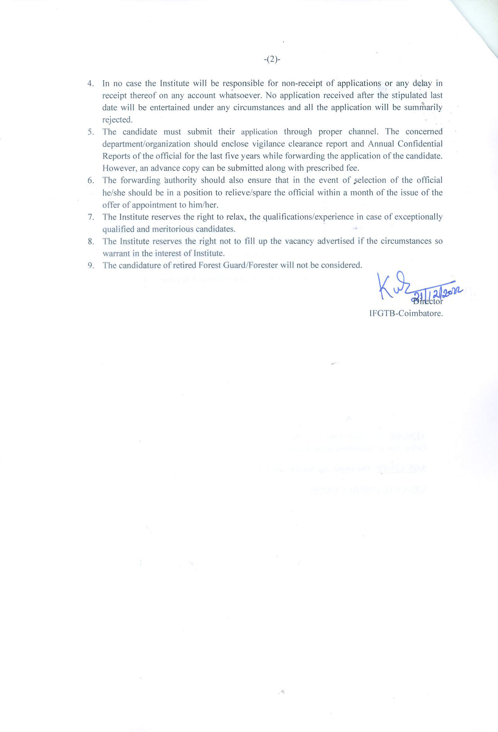

**PROFORMA FOR APPLICATION FOR THE POST OF FORESTER**

1. Name (in Block Letter) :
2. Date of appointment to the present post :
3. Post currently held with pay scale :
4. Date of Birth ( in Christian era) :
5. Father’s/Husband’s Name :

# Address for correspondence :

( in block letters with pin code)

1. Contact Number :
2. E-mail ID :
3. Educational Qualifications :

(SSLC onwards)

1. Details of past service ( chronologically from present position backwards)

|  |  |  |  |  |
| --- | --- | --- | --- | --- |
| State | Forest Division | Post held  (with pay scale) |  | |
| From | To |
|  |  |  |  |  |
|  |  |  |  |  |
|  |  |  |  |  |
|  |  |  |  |  |
|  |  |  |  |  |

1. Details of professional training course :

(Attached copy of Certificate)

1. Date of retirement under the rules of

Central/State Government :

1. Any other information :
2. Bank Draft No. with date and amount:

Place: (Signature of the candidate)

Date:

**PROFORMA FOR APPLICATION FOR THE POST OF DEPUTY RANGER**

1. Name (in Block Letter) :
2. Date of appointment to the present post :
3. Post currently held with pay scale :
4. Date of Birth ( in Christian era) :
5. Father’s/Husband’s Name :
6. Address for correspondence :

( in block letters with pin code)

1. Contact Number :
2. E-mail ID :
3. Educational Qualifications :
4. Details of past service ( chronologically from present position backwards)

|  |  |  |  |  |
| --- | --- | --- | --- | --- |
| State | Forest Division | Post held  (with pay scale) |  | |
| From | To |
|  |  |  |  |  |
|  |  |  |  |  |
|  |  |  |  |  |
|  |  |  |  |  |
|  |  |  |  |  |

1. Details of professional training course :

(Attached copy of Certificate)

1. Date of retirement under the rules of

Central/State Government :

1. Any other information :
2. Bank Draft No. with date and amount:

Place: (Signature of the candidate)

Date:

**Annexure**

Certificate to be furnished by the Employer / Forwarding Authority certified that :

1. The particulars furnished by Shri/Smt. ______________________________ are correct.
2. There is no vigilance / disciplinary case either pending or contemplated against him/her.
3. Integrity of the applicant is certified.
4. Photocopies of the up-to-date ACRs, attested by an officer not below the rank of an Under Secretary to the Govt. of India are enclosed.

Date : (Signature of the Head of the Department /

Forwarding Authority)

Department/Office with seal

Telephone No._________________